Principals and Permitted Staff DPB Questionnaire
Firm name: | Click or tap here to enter text.
DPB Contact Principal: | Click or tap here to enter text.
This form should be completed and returned to | Click or tap here to enter text. | by | Click or tap to enter a date.
If you have any queries please contact: | Click or tap here to enter text.
Reporting period from: | Click or tap to enter a date.
Reporting period to: | Click or tap to enter a date.

You should answer all questions carefully. Your answers will form part of the firm’s annual investment business compliance review, which is a requirement of the firm’s DPB licence.
Please see Part 3, Schedule 2 of the ICAS DPB Handbook for details of regulated activities.

Name of person completing the form: Click or tap here to enter text.
Regulated activities
 | Have you, or any staff under your control, undertaken any of the following activities?
 | Referred work to a PTP where no further involvement whatsoever was taken in the advising process. | Choose an item.
 | Referred work to a PTP, and/or commented on the advice received by the client, but did not make alternative recommendations. | Choose an item.
 | Arranged deals in quoted securities at the request of the client or on the advice of a PTP. | Choose an item.
 | Managed investments in conjunction with a PTP. | Choose an item.
 | Advised on the disposal of investments, other than shares of unquoted companies and rights in a pension scheme or policy. | Choose an item.
 | Advised on transactions in the shares of unquoted companies. | Choose an item.
 | Engaged in corporate finance activity involving transactions in shares of unquoted companies. | Choose an item.
 | Acted as a trustee or personal representative or held a power of attorney where all investment decisions were taken by, or on the advice of, a PTP. | Choose an item.
 | Managed investments without the involvement of a PTP. | Choose an item.
 | Advised on the disposal of rights in a personal pension scheme or policy. | Choose an item.
 | Engaged in corporate finance activity involving transactions in shares of quoted companies. | Choose an item.
 | Advised on the purchase of investments. | Choose an item.
 | Approved investment business advertisements or financial promotions for clients. | Choose an item.
 | Acted as a trustee or personal representative or held a power of attorney where investment decisions were taken without the involvement of a PTP. | Choose an item.
 | Advised on regulated home finance plans. | Choose an item.
 | Advised on general insurance. | Choose an item.
Where the answer to any of the above is Yes, please complete Schedule 1

 | Has the firm received any commission in respect of services you have provided to clients? | Choose an item.
If ‘Yes’, please provide details.
Click or tap here to enter text.
 | Have you carried out any work highlighted above for new clients prior to carrying out any other services or for existing clients where no other services are provided? | Choose an item.
 | Have you referred any party, client or not, to an IFA, broker or other financial services entity not on the firm’s approved list? | Choose an item.
 | Have you taken on any personal appointments, such as a trusteeship, power of attorney or executorship, other than those already reported on a personal appointment notification form? | Choose an item.
 | Have any parties made any complaints about the firm’s investment services other than those already reported on a complaint form? | Choose an item.
 | Have any new client accounts been opened on behalf of clients? | Choose an item.
 | Have you approved any advertisements for the firm other than those notified on an advertisement/promotion approval form? | Choose an item.
 | Have you received, retained or passed on any client property not recorded in the firm’s client property register, no matter for how short a period it was held? | Choose an item.

I have answered the questions above truthfully and honestly, to the best of my knowledge and belief.
I have read the firm’s DPB Manual and the ICAS DPB Handbook.
I have only undertaken regulated activities where I am permitted by the firm to do so.
I have not undertaken any regulated activities for which I am not fully competent and I have obtained sufficient CPD to maintain such competence.
Any staff under my control, and not on the permitted list, have only undertaken regulated activities under my direct supervision.

Signed: | Click or tap here to enter text. | Date: | Click or tap to enter a date.

Schedule 1 – Clients for which regulated activity has been undertaken
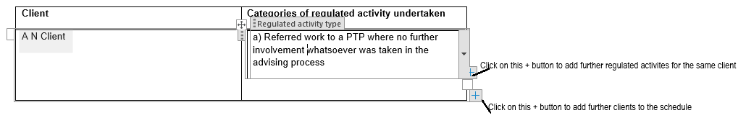
Client | Categories of regulated activity undertaken
Click or tap here to enter text. | Choose an item.

